**Exercise 1 Programs**

***-22I211(Charan V)***

***-D23I431(Fasith Pathan)***

1. **Swap two numbers without using a third variable in Java**

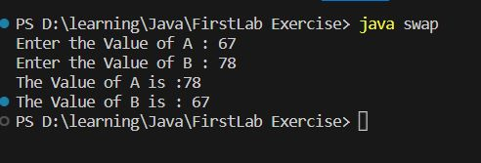

1. **Check if the given number is a prime number.**

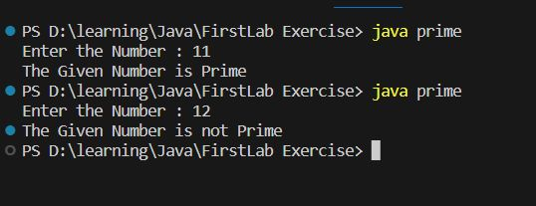

1. **Check if a list of integers contains only odd numbers in Java, if so print yes else no**

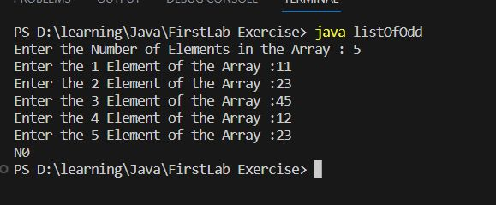

1. **Find the factorial of a given integer**

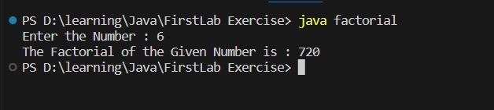

1. **Find the second largest number in an array**

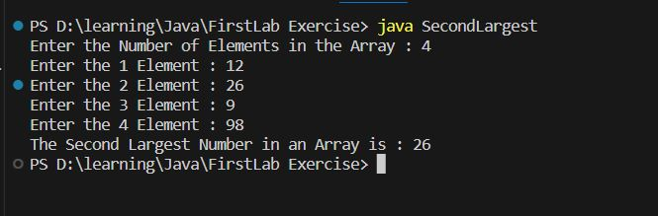

1. **Get n digit number from the user and check if the number is a palindrome**

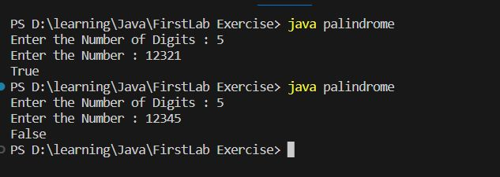

1. **Check if a given number is armstrong number**

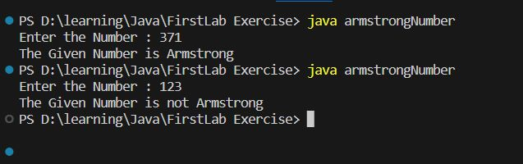

1. **Calculate sum of digits of a given number**

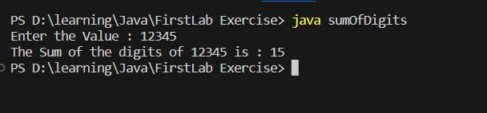

1. **Print Fibonacci series**

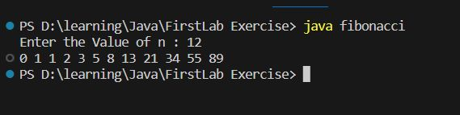

**10.Given a sentence, check if it has vowels in it.**

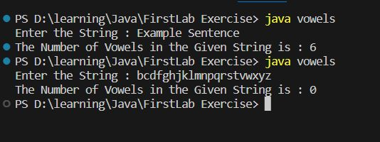

**11. Write a program to reverse the order of words in a given string. For**

**example, if the input is "Hello World", the output should be "World Hello".**

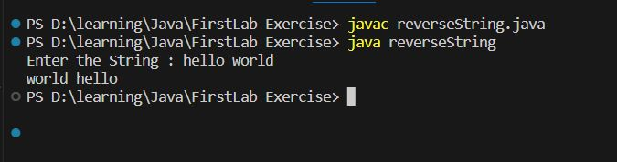

**12. Calculate the greatest common divisor (GCD) of two positive integers**

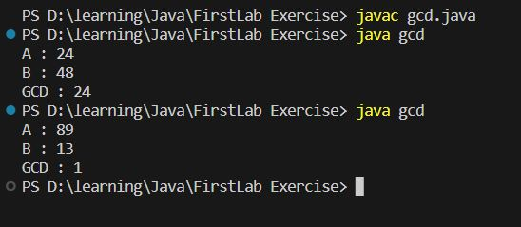

**13. Sort an array of integers in ascending order**

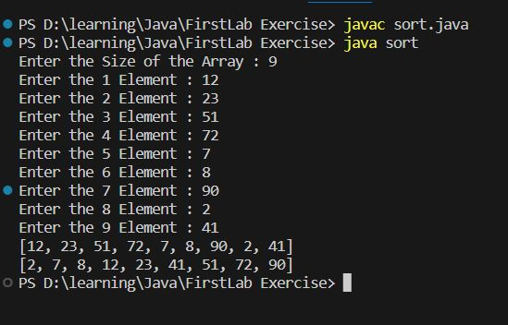

**14. Check if two strings are anagrams (contain the same characters but in a**

**different order).**

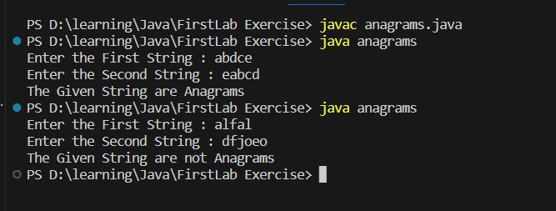

**15. Given a 2D board and a word, find if the word exists in the grid. The word**

**can be constructed from letters of sequentially adjacent cells, where**

**"adjacent" cells are horizontally or vertically neighboring.**

